Intern Name: NANCY(INT00115)  
 Project Duration: 22th June 2025 – 25st June 2025   
Organization: SkilledUp   
Mentor: Aman Chauhan

**SQL Script for Salase Industries**

**create database salesindustry;**

**use salesindustry;**

**CREATE TABLE Customers (**

**CustomerID INT PRIMARY KEY,**

**Name VARCHAR(100),**

**Email VARCHAR(100),**

**Phone VARCHAR(20),**

**City VARCHAR(50),**

**State VARCHAR(50),**

**JoinDate DATE**

**);**

**CREATE TABLE Products (**

**ProductID INT PRIMARY KEY,**

**ProductName VARCHAR(100),**

**Category VARCHAR(50),**

**UnitPrice DECIMAL(10,2),**

**StockQuantity INT**

**);**

**CREATE TABLE Sales (**

**SaleID INT PRIMARY KEY,**

**CustomerID INT,**

**ProductID INT,**

**SaleDate DATE,**

**QuantitySold INT,**

**TotalAmount DECIMAL(10,2),**

**FOREIGN KEY (CustomerID) REFERENCES Customers(CustomerID),**

**FOREIGN KEY (ProductID) REFERENCES Products(ProductID)**

**);**

**CREATE TABLE SalesAgents (**

**AgentID INT PRIMARY KEY,**

**AgentName VARCHAR(100),**

**Region VARCHAR(50),**

**Phone VARCHAR(20),**

**JoiningDate DATE**

**);**

**CREATE TABLE Agent_Sales (**

**SaleID INT,**

**AgentID INT,**

**FOREIGN KEY (SaleID) REFERENCES Sales(SaleID),**

**FOREIGN KEY (AgentID) REFERENCES SalesAgents(AgentID)**

**);**

**INSERT INTO Customers (CustomerID, Name, Email, Phone, City, State, JoinDate) VALUES**

**(1, 'Amit Kumar', 'amitk@example.com', '9998877661', 'Delhi', 'Delhi', '2024-01-10'),**

**(2, 'Sneha Sharma', 'snehas@example.com', '9898989898', 'Mumbai', 'Maharashtra', '2023-12-05'),**

**(3, 'Raj Patel', 'rajp@example.com', '9876543210', 'Ahmedabad', 'Gujarat', '2024-05-12'),**

**(4, 'Priya Singh', 'priyas@example.com', '9123456789', 'Bangalore', 'Karnataka', '2023-11-22'),**

**(5, 'Karan Verma', 'karanv@example.com', '9345678912', 'Hyderabad', 'Telangana', '2024-03-15'),**

**(6, 'Divya Jain', 'divyaj@example.com', '9001122334', 'Kolkata', 'West Bengal', '2024-04-01'),**

**(7, 'Manoj Mehta', 'manojm@example.com', '9887766554', 'Chennai', 'Tamil Nadu', '2025-01-05'),**

**(8, 'Anjali Kapoor', 'anjalik@example.com', '9988776655', 'Pune', 'Maharashtra', '2024-02-19'),**

**(9, 'Ravi Reddy', 'ravir@example.com', '9876123456', 'Secunderabad', 'Telangana', '2023-10-08'),**

**(10, 'Pooja Nair', 'poojan@example.com', '9823456781', 'Kochi', 'Kerala', '2024-06-10');**

**INSERT INTO Products (ProductID, ProductName, Category, UnitPrice, StockQuantity) VALUES**

**(1, 'Toothpaste', 'Personal Care', 45.00, 300),**

**(2, 'Shampoo', 'Personal Care', 120.00, 150),**

**(3, 'Rice (5kg)', 'Food Grains', 350.00, 200),**

**(4, 'Washing Powder', 'Household', 80.00, 500),**

**(5, 'Cooking Oil (1L)', 'Groceries', 130.00, 250),**

**(6, 'Detergent Bar', 'Household', 30.00, 450),**

**(7, 'Biscuits (Pack of 10)', 'Snacks', 90.00, 300),**

**(8, 'Hand Sanitizer', 'Health', 60.00, 180),**

**(9, 'Milk (1L)', 'Dairy', 50.00, 400),**

**(10, 'Tea Powder (500g)', 'Beverages', 180.00, 160);**

**INSERT INTO Sales (SaleID, CustomerID, ProductID, SaleDate, QuantitySold, TotalAmount) VALUES**

**(1, 1, 1, '2024-06-01', 2, 90.00),**

**(2, 2, 3, '2024-06-02', 1, 350.00),**

**(3, 3, 5, '2024-06-03', 3, 390.00),**

**(4, 4, 2, '2024-06-04', 1, 120.00),**

**(5, 5, 6, '2024-06-05', 4, 120.00),**

**(6, 6, 4, '2024-06-06', 2, 160.00),**

**(7, 7, 9, '2024-06-07', 5, 250.00),**

**(8, 8, 10, '2024-06-08', 1, 180.00),**

**(9, 9, 8, '2024-06-09', 2, 120.00),**

**(10, 10, 7, '2024-06-10', 3, 270.00);**

**INSERT INTO SalesAgents (AgentID, AgentName, Region, Phone, JoiningDate) VALUES**

**(1, 'Vikram Rana', 'North', '9990001111', '2023-01-15'),**

**(2, 'Sonal Joshi', 'West', '9887766555', '2022-12-01'),**

**(3, 'Arun Pillai', 'South', '9776655443', '2023-03-20'),**

**(4, 'Reema Das', 'East', '9665544332', '2023-05-11'),**

**(5, 'Faizan Khan', 'Central', '9554433221', '2024-02-14'),**

**(6, 'Neha Mehra', 'North-East', '9443322110', '2024-06-01'),**

**(7, 'Tarun Ahuja', 'West', '9332211009', '2023-07-22'),**

**(8, 'Lavanya Rao', 'South', '9221100998', '2023-08-30'),**

**(9, 'Ritesh Gupta', 'North', '9110099887', '2024-01-05'),**

**(10, 'Meena Yadav', 'East', '9009988776', '2024-03-18');**

**INSERT INTO Agent_Sales (SaleID, AgentID) VALUES**

**(1, 1),**

**(2, 2),**

**(3, 3),**

**(4, 1),**

**(5, 5),**

**(6, 4),**

**(7, 6),**

**(8, 3),**

**(9, 2),**

**(10, 7);**

Questions  **Aggregation Functions (SUM, COUNT, AVG, MAX, MIN)   
1. What is the total sales revenue generated across all products?**

**SELECT SUM(TotalAmount) AS TotalSalesRevenue FROM Sales;**

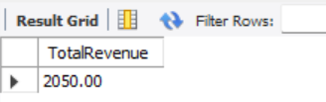

**2. Which product has the highest number of units sold?**

**SELECT ProductID, SUM(QuantitySold) AS TotalUnitsSold FROM Sales GROUP BY ProductID ORDER BY TotalUnitsSold DESC LIMIT 1;**

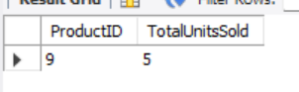

**3. What is the average quantity of products sold per sale?**

**SELECT AVG(QuantitySold) AS AvgQuantityPerSale FROM Sales;**

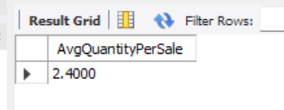

**4. What is the total number of customers who have made purchases?**

**SELECT COUNT(DISTINCT CustomerID) AS TotalCustomers FROM Sales;**

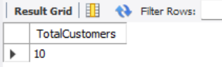

**5. What is the total amount spent by each customer?**

**SELECT CustomerID, SUM(TotalAmount) AS TotalSpent FROM Sales GROUP BY CustomerID;**

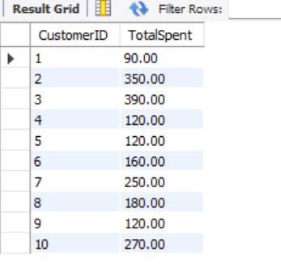

**6. What is the maximum sale amount recorded?**

**SELECT MAX(TotalAmount) AS MaxSaleAmount FROM Sales;**

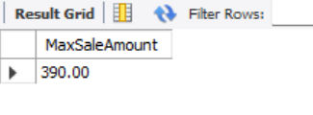

**7. What is the average total amount per sale for each product?**

**SELECT ProductID, AVG(TotalAmount) AS AvgAmountPerProduct FROM Sales GROUP BY ProductID;**

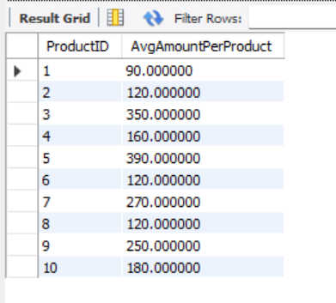

**8. What is the minimum quantity sold in a single transaction?**

**SELECT MIN(QuantitySold) AS MinQuantitySold FROM Sales;**

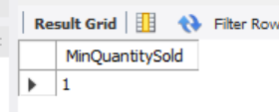

**9. What is the total revenue generated per product category?**

**SELECT P.Category, SUM(S.TotalAmount) AS Revenue FROM Sales S JOIN Products P ON S.ProductID = P.ProductID GROUP BY P.Category;**

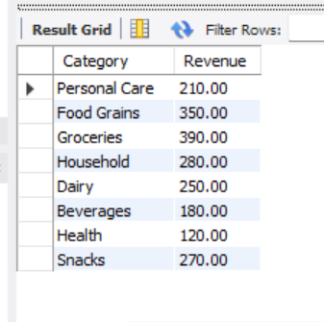

**10. What is the average number of products sold by each sales agent?**

**SELECT A.AgentID, COUNT(S.SaleID) AS TotalProductsSold FROM Agent_Sales AG JOIN Sales S ON AG.SaleID = S.SaleID JOIN SalesAgents A ON AG.AgentID = A.AgentID GROUP BY A.AgentID;**

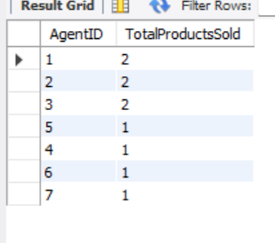

**WHERE Clause**

**11. List all sales where the quantity sold is greater than 10.**

**SELECT * FROM Sales WHERE QuantitySold > 10;**

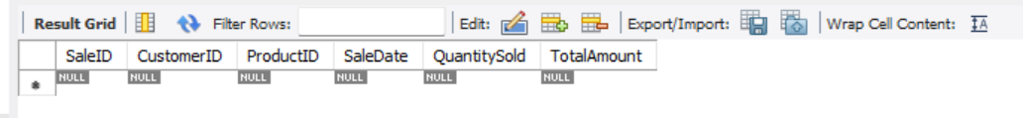

**12. Find all customers from the state of "Delhi".**

**SELECT * FROM Customers WHERE State = 'Delhi';**

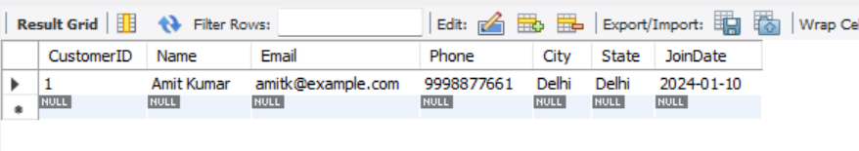

**13. Retrieve all sales made after January 1, 2025.**

**SELECT * FROM Sales WHERE SaleDate > '2025-01-01';**

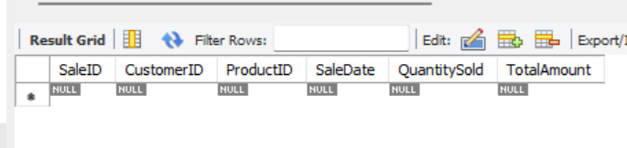

**14. . Find all products with stock quantity less than 100.**

**SELECT * FROM Products WHERE StockQuantity < 100;**

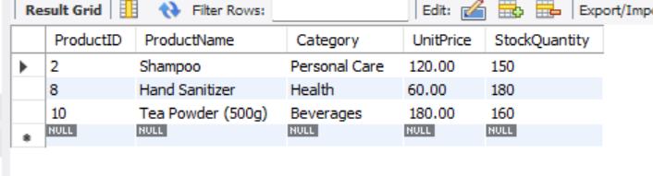

**15. Get details of customers who joined in 2024.**

**SELECT * FROM Customers WHERE YEAR(JoinDate) = 2024;**

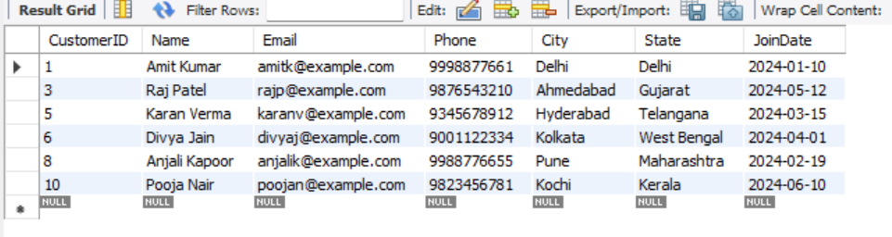

**HAVING Clause**

**16. Which customers have spent more than ₹50,000?**

**SELECT CustomerID, SUM(TotalAmount) AS TotalSpent FROM Sales GROUP BY CustomerID HAVING SUM(TotalAmount) > 50000;**

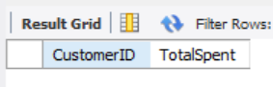

**17. List products that have sold more than 100 units.**

**SELECT ProductID, SUM(QuantitySold) AS TotalUnits FROM Sales GROUP BY ProductID HAVING SUM(QuantitySold) > 100;**

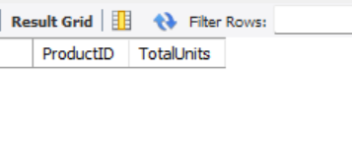

**18. Identify sales agents who have handled sales worth more than ₹1,00,000.**

**SELECT AG.AgentID, SUM(S.TotalAmount) AS TotalHandled FROM Agent_Sales AG JOIN Sales S ON AG.SaleID = S.SaleID GROUP BY AG.AgentID HAVING SUM(S.TotalAmount) > 100000;**

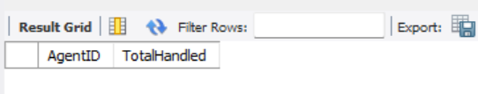

**19. Find product categories that generated revenue over ₹2,00,000.**

**SELECT P.Category, SUM(S.TotalAmount) AS Revenue FROM Sales S JOIN Products P ON S.ProductID = P.ProductID GROUP BY P.Category HAVING SUM(S.TotalAmount) > 200000;**

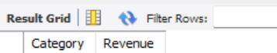

**20. Show cities with more than 5 unique customers.**

**SELECT City, COUNT(DISTINCT CustomerID) AS UniqueCustomers FROM Customers GROUP BY City HAVING COUNT(DISTINCT CustomerID) > 5;**

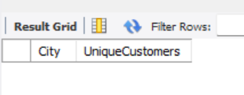

**ORDER BY Clause**

**21. List all products ordered by unit price (high to low).**

**SELECT * FROM Products ORDER BY UnitPrice DESC;**

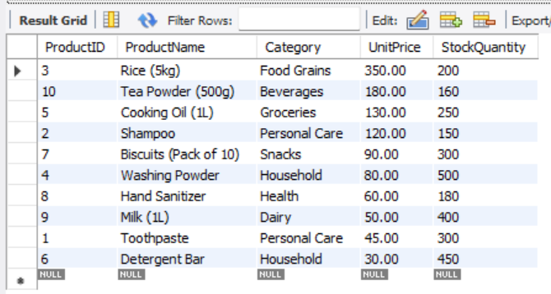

**22. Show top 10 customers by total amount spent.**

**SELECT CustomerID, SUM(TotalAmount) AS TotalSpent FROM Sales GROUP BY CustomerID ORDER BY TotalSpent DESC LIMIT 10;**

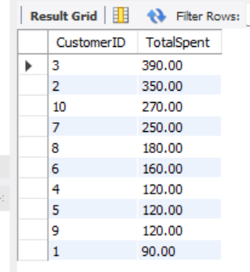

**23. List all sales sorted by date, most recent first.**

**SELECT * FROM Sales ORDER BY SaleDate DESC;**

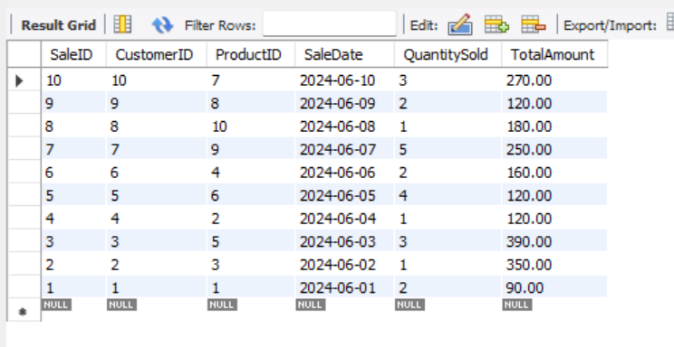

**24. List sales agents ordered by total sales handled.**

**SELECT AG.AgentID, SUM(S.TotalAmount) AS TotalSales FROM Agent_Sales AG JOIN Sales S ON AG.SaleID = S.SaleID GROUP BY AG.AgentID ORDER BY TotalSales DESC;**

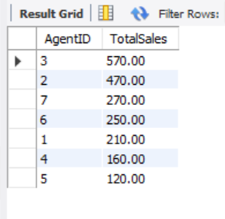

**25. Show product categories sorted by total revenue.**

**SELECT P.Category, SUM(S.TotalAmount) AS TotalRevenue FROM Sales S JOIN Products P ON S.ProductID = P.ProductID GROUP BY P.Category ORDER BY TotalRevenue DESC;**

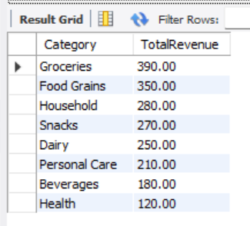

**LIMIT Clause**

**26. Retrieve the top 5 products with the highest revenue.**

**SELECT P.ProductID, SUM(S.TotalAmount) AS Revenue FROM Sales S JOIN Products P ON S.ProductID = P.ProductID GROUP BY P.ProductID ORDER BY Revenue DESC LIMIT 5;**

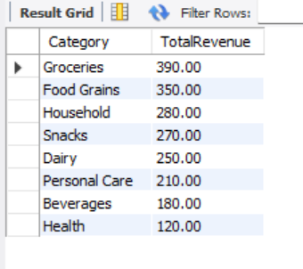

**27. Display the 10 most recent sales transactions.**

**SELECT * FROM Sales ORDER BY SaleDate DESC LIMIT 10;**

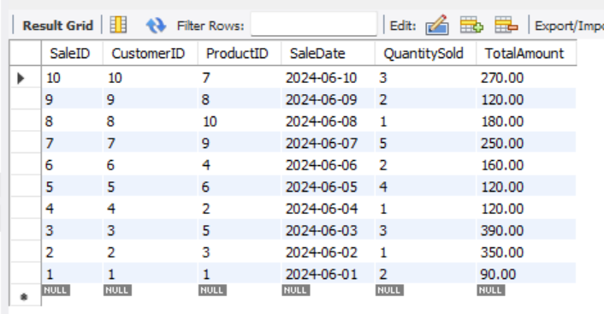

**28. Get the top 3 customers with the highest number of purchases.**

**SELECT CustomerID, COUNT(SaleID) AS Purchases FROM Sales GROUP BY CustomerID ORDER BY Purchases DESC LIMIT 3;**

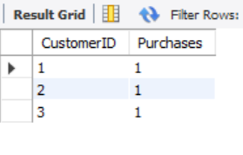

**29. Show the 5 agents with the most number of sales.**

**SELECT AgentID, COUNT(SaleID) AS NumSales FROM Agent_Sales GROUP BY AgentID ORDER BY NumSales DESC LIMIT 5;**

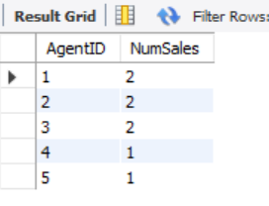

**30. List the latest 5 customers who joined.**

**SELECT * FROM Customers ORDER BY JoinDate DESC LIMIT 5;**

